Chapter 4, Solution 11.

Let v_{o} = v₁ + v₂, where v₁ and v₂ are due to the 6-A and 80-V sources respectively. To find v₁, consider the circuit below.

40 Ω
6 A
+
_
4 i₁
V₁
10 Ω
20 Ω
I₁
v_{a}

v_{b}

At node a,
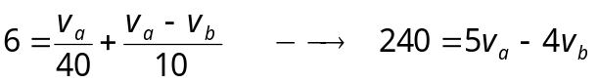 (1)

At node b,
–I₁ – 4I₁ + (v_{b} – 0)/20 = 0 or v_{b} = 100I₁

But 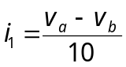 which leads to 100(v_{a}–v_{b})10 = v_{b} or v_{b} = 0.9091v_{a} (2)

Substituting (2) into (1),

5v_{a} – 3.636v_{a} = 240 or v_{a} = 175.95 and v_{b} = 159.96

However, v₁ = v_{a} – v_{b} = 15.99 V.

To find v₂, consider the circuit below.

10 Ω
20 Ω
i_{o}
v_{c}
40 Ω
30 V
+
_
4 i_{o}
v₂
–
+



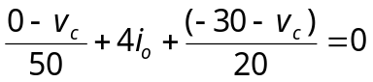
But 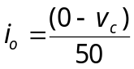

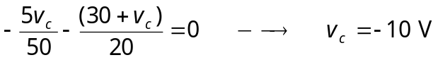
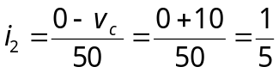
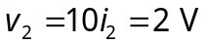

v_{o} = v₁ + v₂ =15.99 + 2 = 17.99 V and i_{o} = v_{o}/10= 1.799 A.

